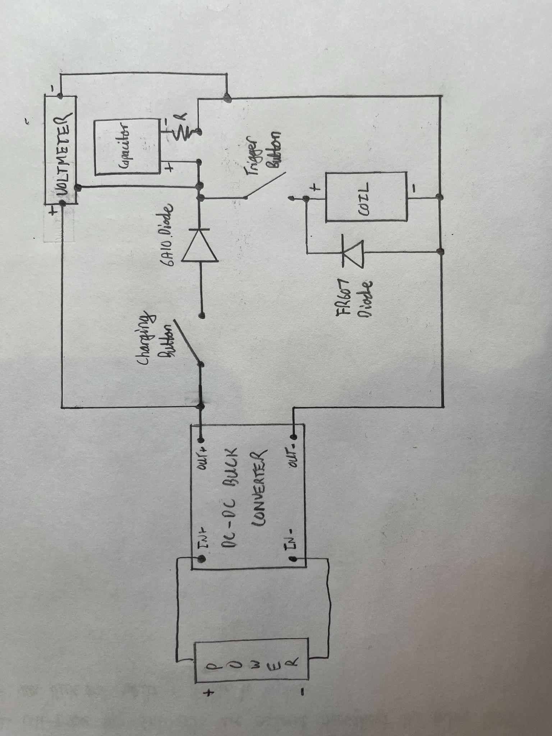

BOM

DC-DC Buck Converter - <https://www.amazon.ca/Converter-Ajustable-Step-down-Converters-1-25V-35V/dp/B074J4DLWQ/ref=asc_df_B074J4DLWQ/?tag=googleshopc0c-20&linkCode=df0&hvadid=335365451913&hvpos=&hvnetw=g&hvrand=10149109205093010389&hvpone=&hvptwo=&hvqmt=&hvdev=c&hvdvcmdl=&hvlocint=&hvlocphy=9061009&hvtargid=pla-899437512675&psc=1>

Charging Button (Momentary Push Button) - <https://www.digikey.ca/en/products/detail/omron-automation-and-safety/A3AA-90K1-00L/672537>

6A10 Diode - <https://www.digikey.ca/en/products/detail/comchip-technology/6A10-G/3308090>

Capacitor -

<https://www.digikey.ca/en/products/detail/chinsan-elite/PK2W681MND3050RY/16496987>

Resistor 1.5kOhm - Myhal

Voltmeter Display - <https://www.digikey.ca/en/products/detail/selec-controls-usa-inc/MV15-110V-CU-ROHS/15954477>

FR607 Diode - <https://www.digikey.ca/en/products/detail/micro-commercial-co/FR607GP-TP/8018631>

Coil Holder - 3D Printed (Free)

Coil Wire - <https://www.digikey.ca/en/products/detail/cnc-tech/610220/4924055>

Trigger Button (toggle switch) - <https://www.digikey.ca/en/products/detail/nkk-switches/S301/1006974>